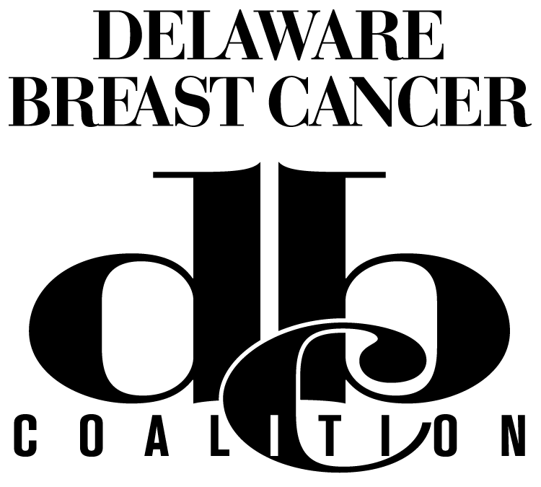
Sponsor and Exhibitor Registration Form
20th Annual Breast Cancer Update
Shoot For The Moon
Tuesday, April 4, 2017
The Rollins Center, Dover Downs Hotel

Please consider serving as a sponsor or exhibitor at our upcoming 20th Annual DBCC Breast Cancer Update. We anticipate over 300 attendees including survivors, caregivers, medical care providers and members of the general public. Please review the enclosed options for sponsoring and exhibiting at the Update. Your generous commitment to the fight against breast cancer will be acknowledged prominently in all program materials and at the event.

Company or organization:
Representatives/Exhibitors:
Mailing address:
City: |  |  |  |  | State: |  |  |  | Zip:
Contact Person: |  |  |  |  |  |  | Phone:
E-mail: |  |  |  |  |  |  | Fax:

See Reverse for Details

$5,000 Gold Sponsor

$3,000 Founders

$1,500 Medical Leaders

$500 Friends

$100 Non-Profit Exhibitors

Unfortunately we are unable to participate but would like to make a donation to DBCC.

Payment Information

Payment: Check MC Visa AMEX Discover
Checks should be made payable to the Delaware Breast Cancer Coalition, Inc. Tax ID: 52-2045298

Card #

Exp. Signature

Name on Card

Billing Address

Zip Amount

Please complete this form and return to DBCC by January 31 to meet our printing deadline for the brochure. All sponsorship and exhibitor forms and payment should be received by February 28. Please provide a high resolution electronic business logo emailed to dbcc@debreastcancer.org.

We look forward to seeing you on April 4. If you have any questions, please call (302) 778-1102, ext. 1020. Thank you for joining DBCC in the fight against breast cancer with your support.

Delaware Breast Cancer Coalition, Inc. 111 W. 11th Street, Suite 3, Wilmington, DE 19801
Phone: 302-778-1102 Fax: 302-778-1104 Web: www.debreastcancer.org
Sponsor and Exhibitor Registration Form
20th Annual Breast Cancer Update
Shoot For The Moon
Tuesday, April 4, 2017
The Rollins Center, Dover Downs Hotel

$5,000 Gold Sponsorship
- Company logo displayed on DBCC website with link to company site.
- Company logo highlighted on all online, printed materials and advertisements.
- Six-foot exhibitor table with registration for up to eight (8) people.
- Recognition during the program.

$3,000 Founders
- Company logo displayed on all online, printed materials and advertisements.
- Six-foot exhibitor table with registration for up to six (6) people.
- Recognition during the program.

$1,500 Medical Leaders
- Company logo displayed on all online, printed materials and advertisements.
- Six-foot exhibitor table with registration for up to four (4) people.
- Recognition at the event.

$500 Friends
- Company logo displayed on all online, printed materials and advertisements.
- Six-foot exhibitor table with registration for up to two (2) people.
- Recognition at the event.

$100 Non-Profit Exhibitors
- Six-foot exhibitor table.
- Registration for (1) person with recognition at the event. (Additional attendees should register to attend.)

Commitment and Logo Deadline is January 31 for brochure printing.
All sponsorship & exhibitor forms and payment should be received by February 28.

